**B. Implementation of digital anti-aliasing filters on a DSP**

1. **Plot of the sample signal x(n) = 0.1 * sin(0.25 * 1.0 * n);**

The Time domain representation of the signal has been ploteed in CCES as the figure below, where its x axis is time(s) and y axis is amplitude.

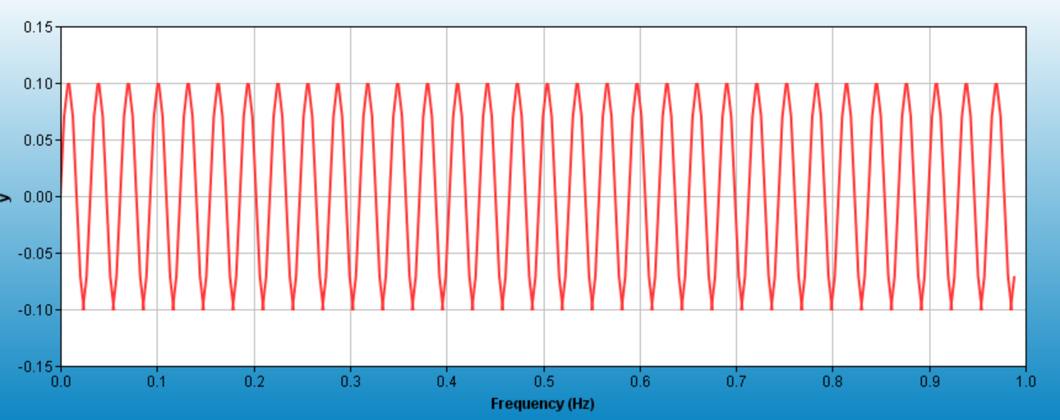

The frequency domain representation of the signal is shown in the figure below, where the x axis is frequency(Hz), y axis is amplitude.



1. **Write a c-program which generates two sequences of 256 samples of x(t), using the sampling frequencies F1 = 1.2Hz and F2 = 4.8Hz.**

**The code used to generate the 2 signals are attached below.**

#include <stdio.h>

#include <math.h>

*// Globals*

#define N 256

#define PI 3.1415

float x1[N];

int main(void)

{

int i;

float omega1 = 0.25 * PI, omega2 = 1.9 * PI;

float T2 = 1/4.8;

float T1 = 1/1.2;

float a=0.12;

float alpha1 = 0.593, alpha2 = 0.464;

x1[0] = exp(-a*0*T1)*cos(omega1*0*T1) + 0.1*sin(omega2*0*T1);

x2[0] = exp(-a*0*T2)*cos(omega1*0*T2) + 0.1*sin(omega2*0*T2);

**for** (i = 0; i < N; i++)

{

x1[i] = exp(-a*i*T1)*cos(omega1*i*T1) + 0.1*sin(omega2*i*T1);

x2[i] = exp(-a*i*T2)*cos(omega1*i*T2) + 0.1*sin(omega2*i*T2);

}

printf("Done.**\n**");

**return** 0;

}

1. **Use the plot facility within CCES to plot the sampled signals in the time domain and in the frequency domain. Comment on the results.**

To predict how the signal is going to behave, Matlab was used to plot x1 and x2 in time and frequency domain. (Code attached in appendix).

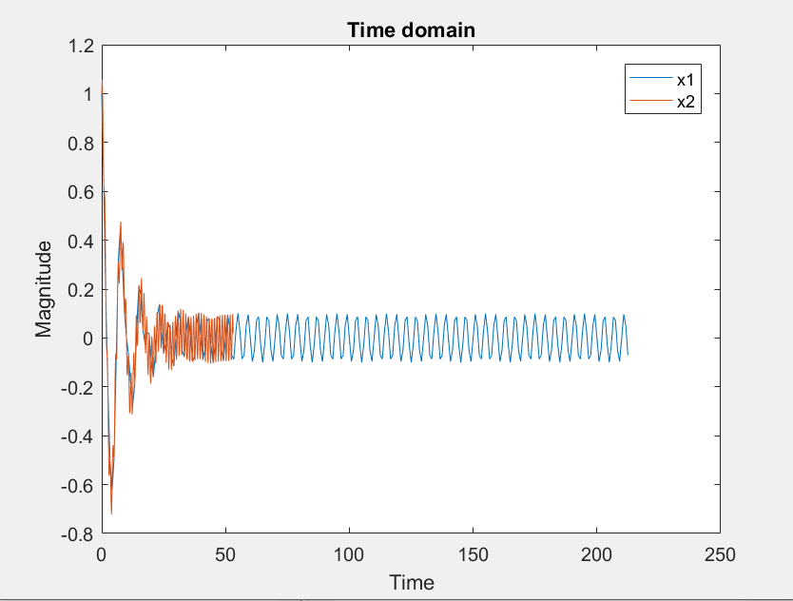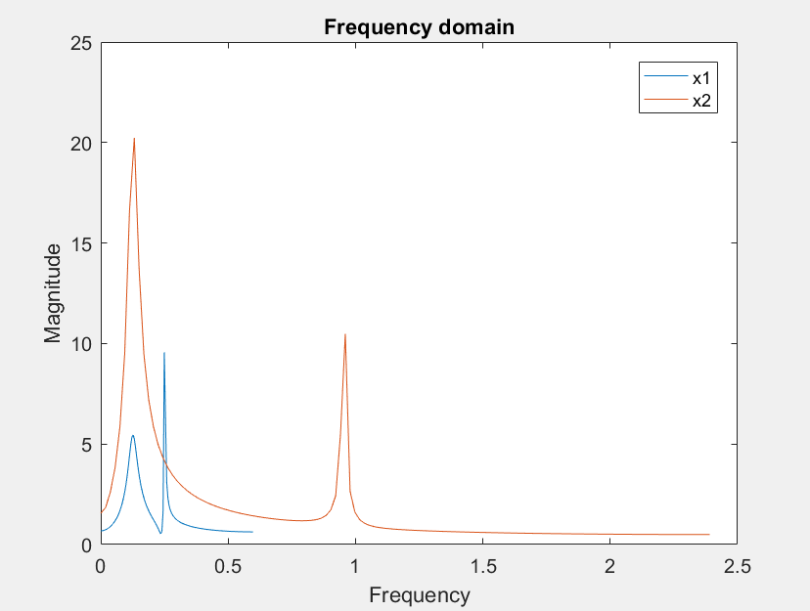

**The result generated by CESS are shown as below**

**Time domain plot. x axis: sample time, y axis: magnitude(linear scale)**

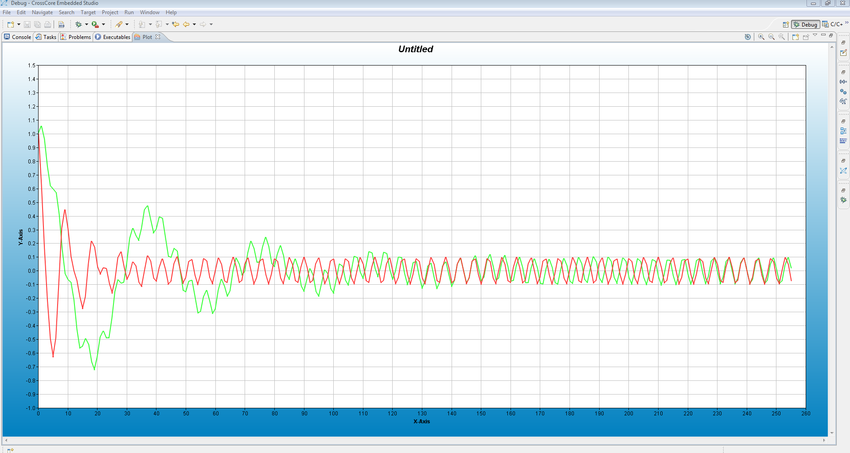

**Frequency domain plot. x axis: frequency(Hz), y axis: magnitude(linear scale)**

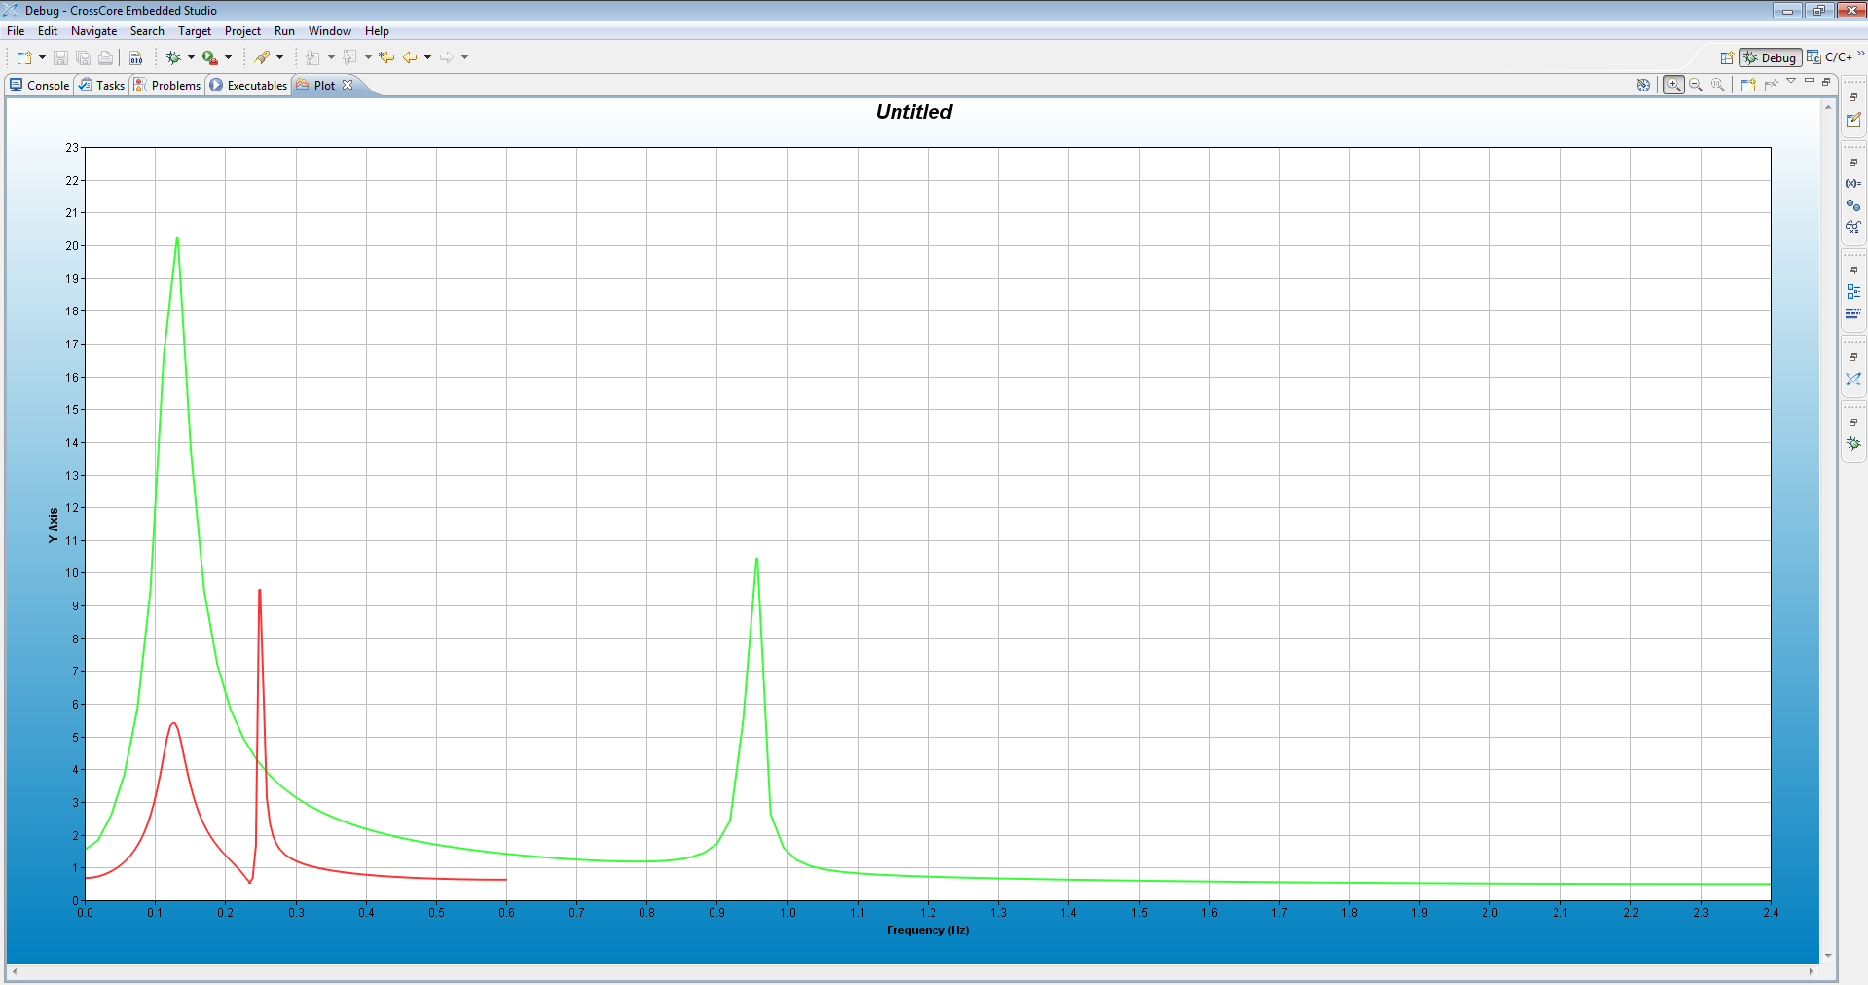

**As the plots above show, the signal generated in the DSP board are identical to that simulated in Matlab.**

**Comment on the result:**

**Theoretically speaking, the signal should generate two peaks at $f1= \frac{Ω_{1}}{2*pi}=\frac{0.25*pi}{2*pi}= 0.125Hz$, and $f_{2}= \frac{Ω_{2}}{2*pi}=\frac{1.9*pi}{2*pi}= 0.95Hz$. Which is matching up with what signal x2(the green trace) in the CCES FFT plot.**

**However, there are two facts about the signal x1’s FFT plot were noticed in the FFT plot: 1. The 0.95Hz peak was missing, 2. There is an “unpredicted” peak between the region of 0.2-0.3Hz. Fact 1 might due to the sampling angular velocity $Ω_{sampling1} =1.2*2pi < 2Ω_{2}=2*1.9*2pi$. When the sampling frequency is less than $2Ω_{max}$ of the signal, high frequency component of the signal will be distorted while sampling. Fact 2 is due to the fact that the sampling frequency is too low and it cause the folding effect around $\frac{f_{samling}}{2}=\frac{1.2}{2}=0.6Hz.$ The frequency component from $f_{2}= \frac{Ω_{2}}{2*pi}=\frac{1.9*pi}{2*pi}= 0.95Hz$ is distorted and folded back to 0.6-(0.95-0.6) = 0.25Hz, which fell into the 0.2-0.3Hz region we mentioned in the last paragraph.**

1. **Analysis of the first order and second order filter**